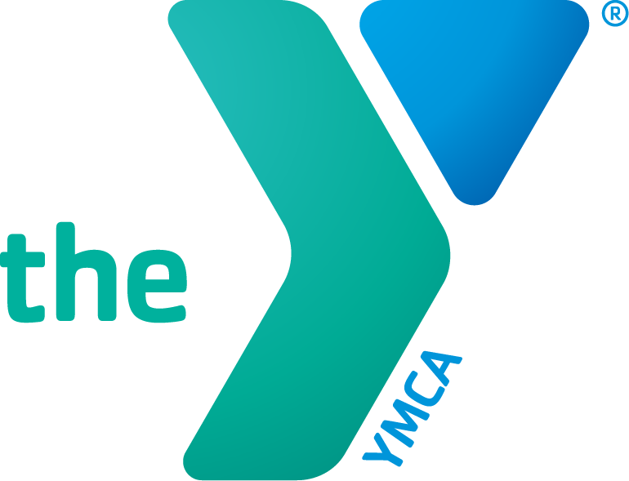
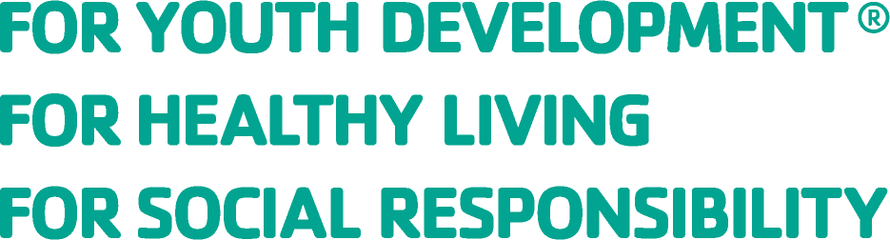

DEMAKES FAMILY YMCA
LOBBY CAFÉ LEASE
REQUEST FOR PROPOSAL

SUBMISSION DEADLINE: April 14, 2023

- Background: The Demakes Family YMCA (“the YMCA”) invites the submission of proposals by qualified persons and businesses to operate a full-time food and beverage service venue at its space called “The Café” located inside our Demakes Family YMCA facility at 40 Neptune Blvd., Lynn, MA 01902. The Café is located in the YMCA’s first-floor lobby.

The YMCA services approximately 1000 guests daily, and also receives additional guests visiting our Community Space area (located directly across from The Café).

The commercial space available for lease is comprised of two areas: (1) the lobby café’ area and (2) the preparation and storage area (located directly behind the lobby café area). There is also a designated café seating area. The preparation and storage area also includes use of its commercial grade kitchen equipment that is primarily used for Café and catering services. The lobby café space and the preparation and storage space is approximately 1,025 sq. ft. The Café operator will have access to The YMCA’s commercial kitchen for preparation and cooking needs; however, the YMCA reserves the right to use, program and rent to others.

- Hours of Operation (at a minimum):
  - Monday – Friday: 7 am – 1 pm; 3 pm – 7 pm
  - Saturday – 8 am – 2 pm
  - Sunday – Closed

- Rent:
  - Tenant will pay a flat monthly rental payment of $2,500 during the stated term.

- Objectives: The YMCA will seek proposals to fulfill the following objectives.
  - To identify a professional person or organization with the ability and experience to operate and manage a full-service food and beverage Café in The YMCA’s Café space.
  - To support and create a thriving gathering place for the YMCA members and community.
  - To have the Café space be a revenue source for both The YMCA and the Café Operator.
  - The YMCA promotes the health and well-being of all. Therefore, the menu must represent these efforts of improving the health of the community. Soda, candy, etc. will not be permitted for sale.

- Proposal Deadline: Respondents must complete the “Respondent’s Proposal and Qualifications Questionnaire” and submit their proposal by email no later than 5:00 pm on Friday, April 14, 2023 to Andrea Baez abaez@metronorthymca.org and Lisa Ferraro lferraro@metronorthymca.org.
All proposals must be clearly marked “Proposal for Lobby Café Lease” in the subject line. Late proposals will be rejected.

Respondent's Proposal and Qualifications Questionnaire
Respondent must use this document to submit Respondent's proposal. The Demakes Family YMCA will use the following information to evaluate the respondents.
Key Contact Information

Name of Key Contact
Position within the entity
(e.g., owner, officer, partner, etc.):
Address
Telephone
Email Address

Section 1 - Proposing Legal Entity
Please provide the legal entity information (exactly as it will be stated in the Lease)

Name of Legal Entity
[ ] Individual [ ] Partnership [ ] Joint Venture
[ ] Limited Liability Company [ ]Corporation [ ]Other (include explanation below)
Date Established
Registered Address
Authorized Representative's Name

Title of Authorized
Representative

Section 2 - Relevant Experience and Qualifications
Respondent should complete the following section which provides a list of current or former cafe or restaurant business(s) operated by Respondent, number of years at that location, size, monthly gross and net revenue, and monthly rent paid. If necessary, Respondent can also attach a short narrative response, limited to one page, that describes Respondent's relevant experience and operating history. For new entities, the narrative should demonstrate that the principal of the new entity has qualifying experience managing a similar cafe or eatery.

Number of Existing Business(es)
Number of Existing Employees

Name and | Years of | Description of | Monthly | Monthly | Monthly
Address of | Operation | size (e.g., coffee | Gross | Net | Rent
Current and Prior Cafe(s) or |  | cart, cafe, full scale restaurant) | Revenue | Revenue
Restaurant(s)
operated by
Respondent (Please indicate Current or Prior)

Section 2 - Relevant Experience and Qualifications (Continued)

- Please provide a description of how the Café at the Demakes Family YMCA will be operated? Describe your vision for the Café. Also, please describe how the Café will be managed, including the number of hours that key employees will actively spend on-site.

- Optional Narrative for Section 2: A short narrative response, limited to one page, which describes Respondent's relevant experience and operating history. For new entities, the narrative should demonstrate that the principal of the new entity has qualifying experience managing a similar cafe or eatery.

Section 3 - Financial Capacity

- Respondent should demonstrate that it has the financial resources to (i) undertake this opportunity, including the demonstrated ability to manage, market, and operate its organization, (ii) pay rent and provide a security deposit, (iii) procure the required insurance, and (iv) hire qualified staff.

Section 4 - Proposed Menu
- Attach a proposed menu.

Affirmative Statement of Accuracy
- The undersigned represents and warrants to the Demakes Family YMCA as follows:
  - the undersigned person(s) are authorized representatives of Respondent.
  - the person(s) signing below is authorized by Respondent to obligate respondent to perform the commitments contained in the Proposal.
  - all information submitted by Respondent in the Proposal is complete, accurate, and truthful; and
  - submission of this Proposal constitutes a representation by Respondent that it is willing and able to perform the commitments contained in this Proposal.
  - the Demakes Family YMCA’s issuance of this RFP is not a promise or agreement that the YMCA will enter into any lease.

Name __________________________________
Title ___________________________________
Date ____________________________________

Submit proposal by email no later than 5:00 pm on Friday, April 14, 2023 to Andrea Baez abaez@metronorthymca.org and Lisa Ferraro lferraro@metronorthymca.org. All proposals must be clearly marked “Proposal for Lobby Café Lease” in the subject line. Late proposals will be rejected.

